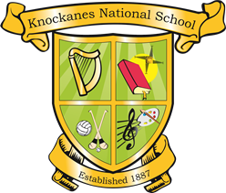

Knockanes National School
ANNUAL ADMISSION NOTICE
in respect of admissions to the 2026/2027 school year

Admission Policy and Application Form
A copy of the school’s Admission Policy and the Application Form for Admission for the 2026/27 School Year is available as follows: –
On request: By emailing knockanesnationalschool@gmail.com or writing to: Knockanes National School, Headford, Killarney, Co. Kerry, V93HX80
On school website: www.knockanesns.ie

PART 1 - Admissions to the 2025/26 school year
Application and Decision Dates for admission to 2025/26 School Year:
The following are the dates applicable for admission to Junior Infants/First Year:

The school will commence accepting applications for admission on | 2nd October 2025
The school shall cease accepting applications for admission on | 31stMarch 2025
The date by which applicants will be notified of the decision on their application is | 30th April 2025
The period within which applicants must confirm acceptance of an offer of admission is | 1 month

Note: the school will consider and issue decisions on late applications in accordance with the school’s admission policy.

Number of places being made available in 2025/26

The number of places being made available in junior infants is | 25
The number of places being made available in the special class catering for children who are Deaf and Hard of Hearing is | 5

